Guided Capstone Project Report

Introduction:

Nestled in the picturesque landscapes of Montana, Big Mountain Resort stands as a premier ski destination, boasting 105 trails and drawing in an impressive 350,000 annual visitors. However, recent expansion efforts, including an additional chair lift, have led to a notable rise in operating costs, reaching $1,540,000. This report seeks to harness data-driven insights to fine-tune Big Mountain's pricing strategy, aiming for both optimal revenue generation and an increase in customer satisfaction.

Problem statement:

Our hypothesis hinges on a comprehensive analysis of facility usage, competitive pricing, and identification of cost-cutting opportunities. Through this exploration, we aim to recommend an adjusted pricing strategy that will increase revenue for Big Mountain Resort in the next fiscal year without compromising customer satisfaction.

Scope of Solution Space:

Our approach included analyzing historical data from 330 resorts, developing a pricing model, and evaluating cost-cutting measures. Key focus areas include facility usage, pricing, and customer satisfaction to provide a comprehensive solution.

Data Wrangling:

The analysis of 'ski_resort_data.csv' exposed challenges like missing values and duplicates, which were effectively resolved in the cleaned dataset, 'ski_data_cleaned.csv', positioning Big Mountain Resort competitively. Notably, dynamic pricing strategies were evident among resorts, showcasing consistent average prices between weekdays and weekends. The scatterplot below accentuates the dynamic pricing nuances across all resorts, providing a visual insight into the pricing dynamics for each facility.

Exploratory Data Analysis (EDA):

To uncover trends, patterns, and actionable insights in the data, the initial exploration focused on the relationship between the total number of resorts by population and total number of resorts by area. While this didn't yield specific insights for Big Mountain Resort, it provided clarity on certain aspects. The subsequent exploration delved into relationships between key components such as vertical drop, years open, or skiable areas and the price in each state, utilizing Principal Component Analysis (PCA). The first two components were found to account for 75% of the variance, with the first four accounting for 95%. A heatmap visualization highlighted clear positive correlations with features like fastQuads, Runs, SnowMaking_Ac, and resort_night_skiing_state_ratio in the "AdultWeekend" row.

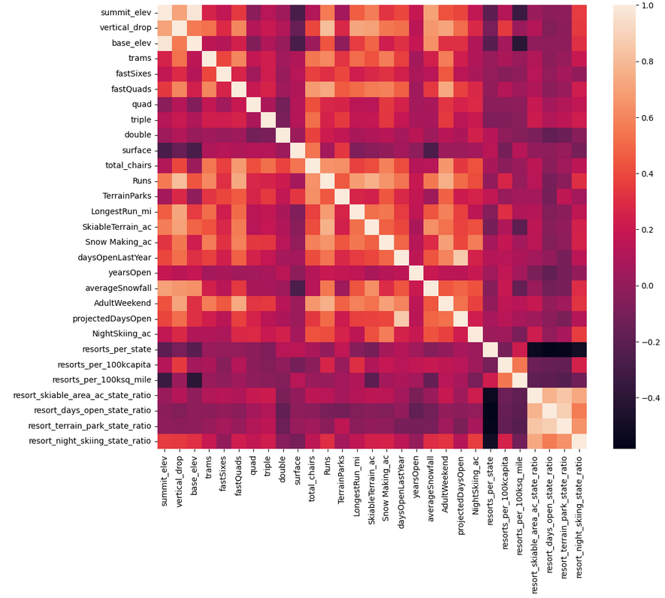

Pre-processing and Training Data:

In the model development phase, initial attempts using the mean of prices fell short in accuracy compared to linear and random forest models. Employing median and mean values in the linear model resulted in an average prediction error of approximately $9. Cross-validation identified eight key features, and the random forest model emerged as the preferred choice, consistently outperforming the linear model with a lower mean absolute error. Key features, including vertical_drop, Snow Making_ac, total_chairs, fastQuads, Runs, LongestRun_mi, trams, and SkiableTerrain_ac, were visualized through a bar chart, emphasizing their significance in predicting prices.

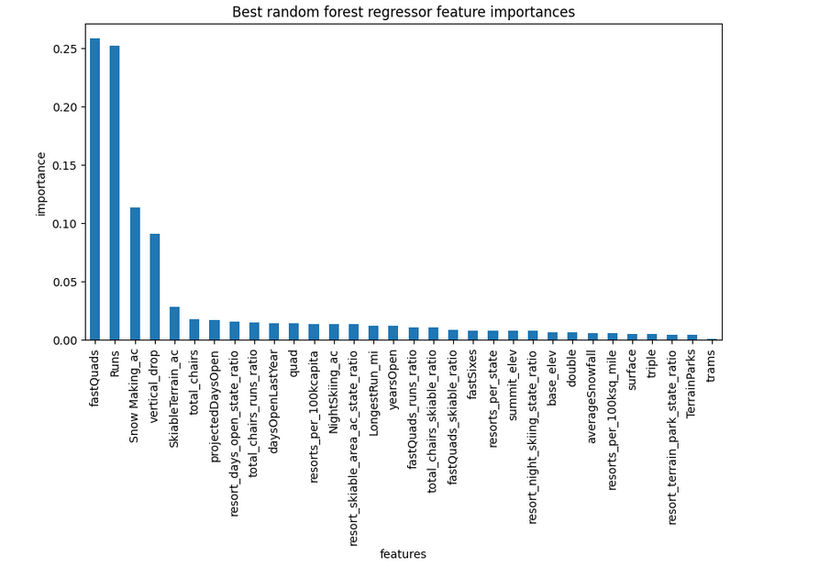

Model Preprocessing with Feature Engineering:

Model development began with an initial assessment using mean ticket prices, progressing to explore linear models with feature engineering. Cross-validation identified eight key features. Subsequent exploration into a random forest model revealed its superiority with consistent performance and a lower mean absolute error. The model emphasized Big Mountain Resort's exceptional standing in various categories, resulting in a modeled price of $96.62, significantly surpassing the current $81.00. The accompanying bar charts highlighted the resort's high standing during the model development phase.

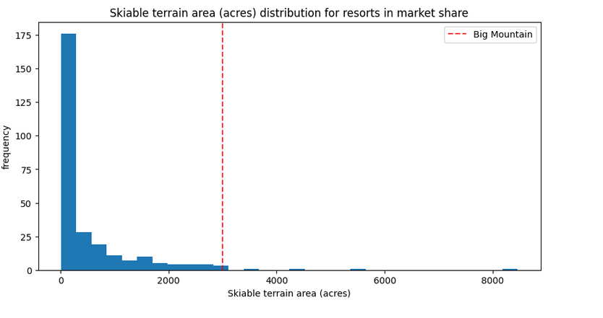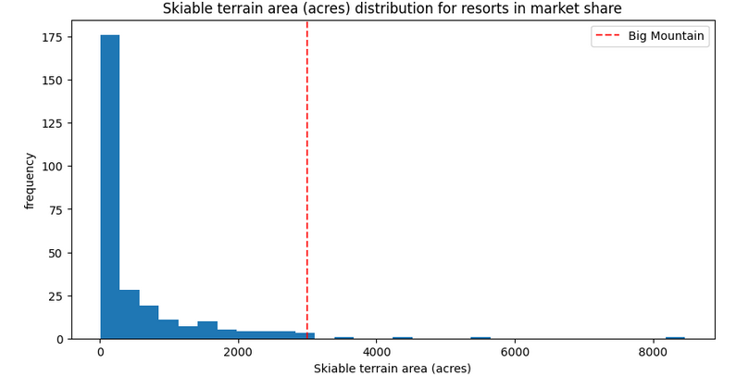

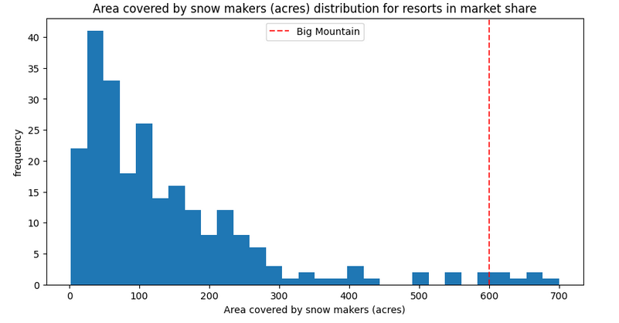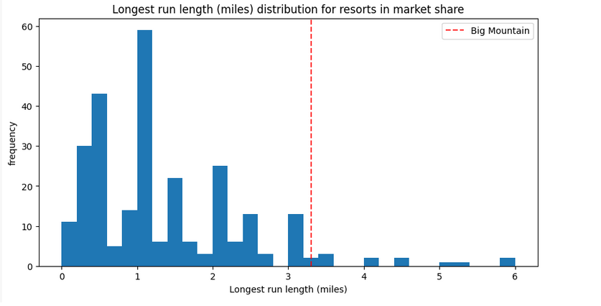

Winning Model and Pricing Recommendation:

Scenario 3 proposes a ticket price increase of $13.22, offering a lucrative opportunity for increased revenue. The model also recommends the closure of 6-10 underutilized runs, a reduction in vertical drop by 150 feet, and an expansion of snowmaking cover by 2 acres. This comprehensive strategy positions Big Mountain Resort for sustained success and competitiveness.

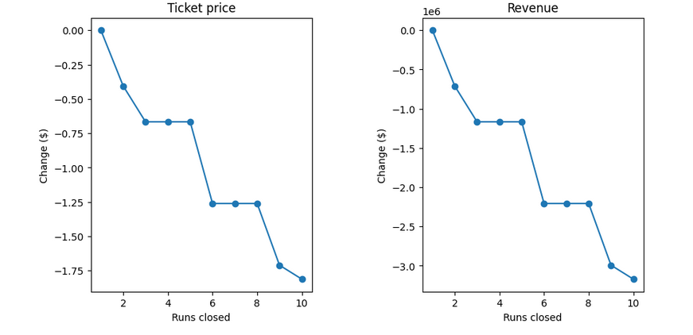

Conclusion:

The exploration through data analysis and model development, enhanced by visualizations, has provided insights into dynamic pricing strategies and influential features. The random forest model, specifically in Scenario 3, emerges as the preferred option for predicting ticket prices. Further refinement and validation of this model will be crucial for successful implementation as we move forward.